Bluetooth tool of Solarman pro APP (on android) to send APN settings

- Download Solarman pro app and access Bluetooth Tools

https://play.google.com/store/apps/details?id=com.igen.solarmanpro&hl=en&gl=US

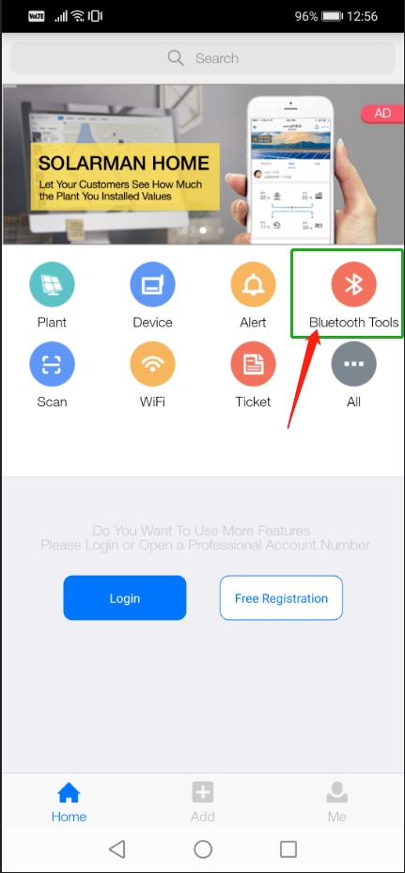

- Allow Solarman Pro App to connect via the Bluetooth and search for GPRS device and select the one nmed SN XXXXX(serial num,ber on your GPRS logger).

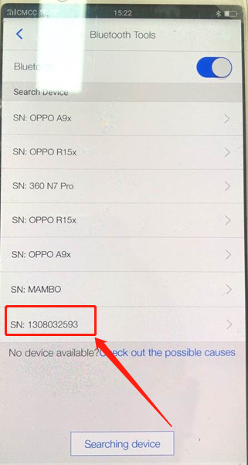

- Select Settings option and input password for Settings provided by Solis engineer.

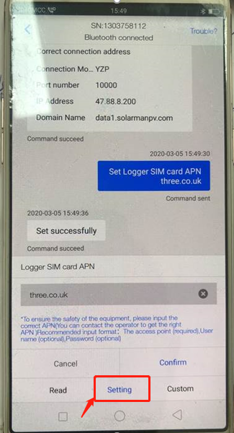

- Send command AT+YZAPN in Custom (input password for Custom provided by Solis engineer)

